Protocol Pillar-Modiolar Assessment

1. Place spots on IHC nuclei and draw volumes as normal
2. Select CTBP2 channel only because the SNR is better
3. Create new surface called ‘IHC masks’ and skip automatic creation
4. Reset view and set perspective to orthogonal
5. On the Draw 🡪 Contour 🡪 Board tab, set resolution manual and specify 512, 512 and click draw
6. Draw around the synapse bundle of a single IHC and take a big section incl OHC for orientation

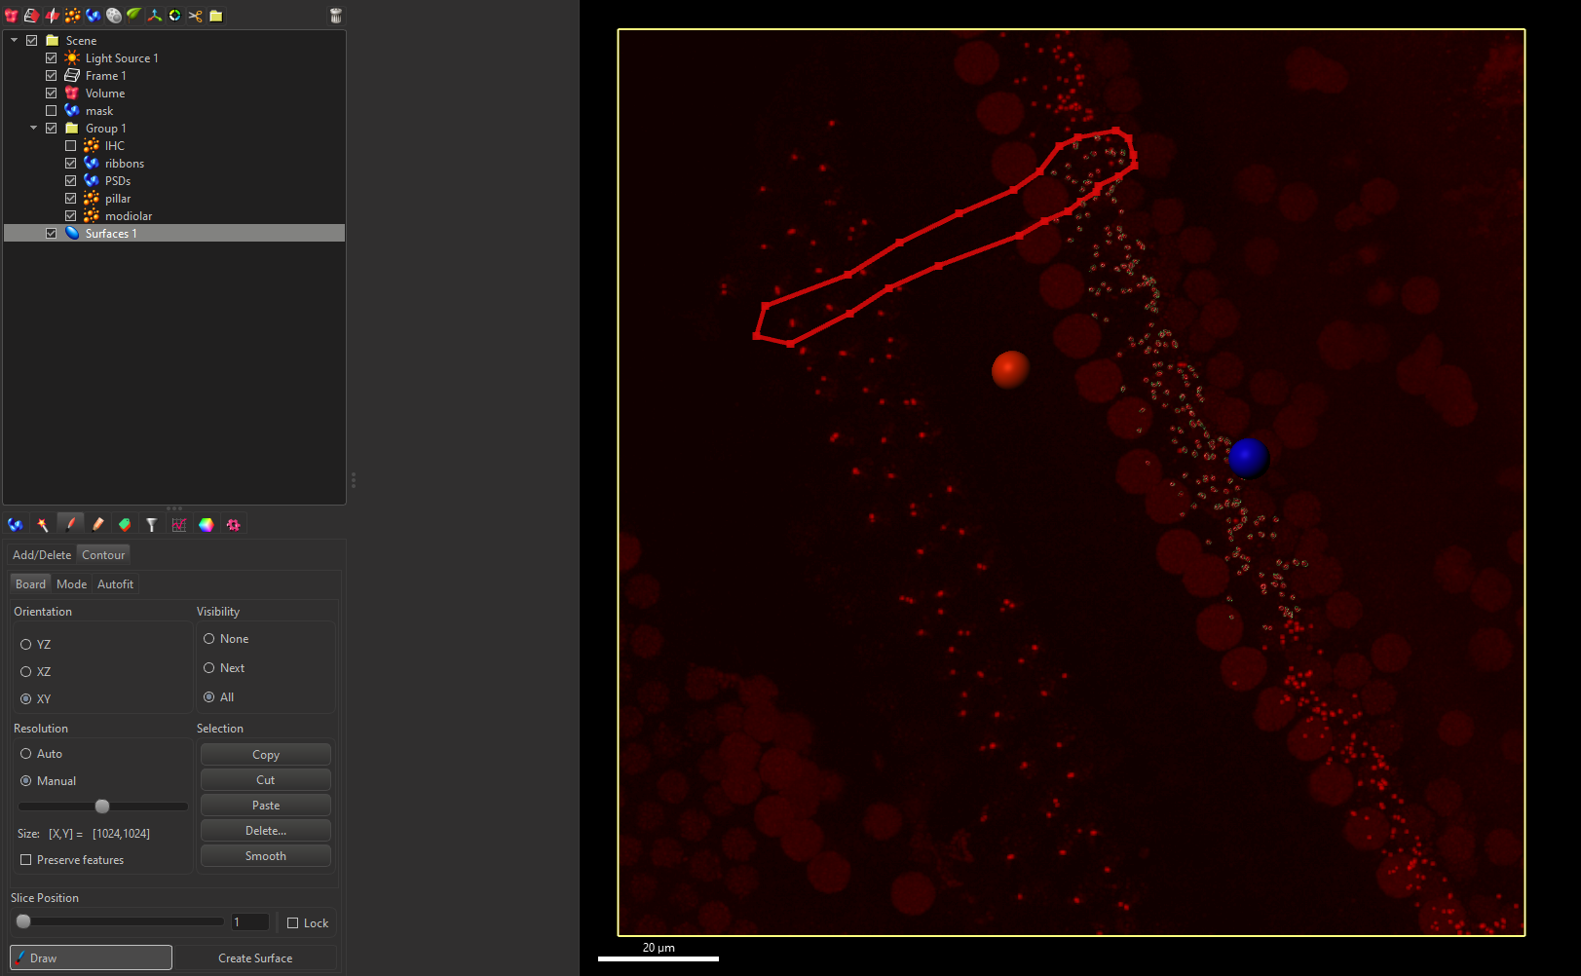

1. Copy contour, go to top slice and paste, create surface
2. Delete contour lines and draw in the next IHCs until all surfaces have been created
3. Continue drawing all IHCs that are included in analysis

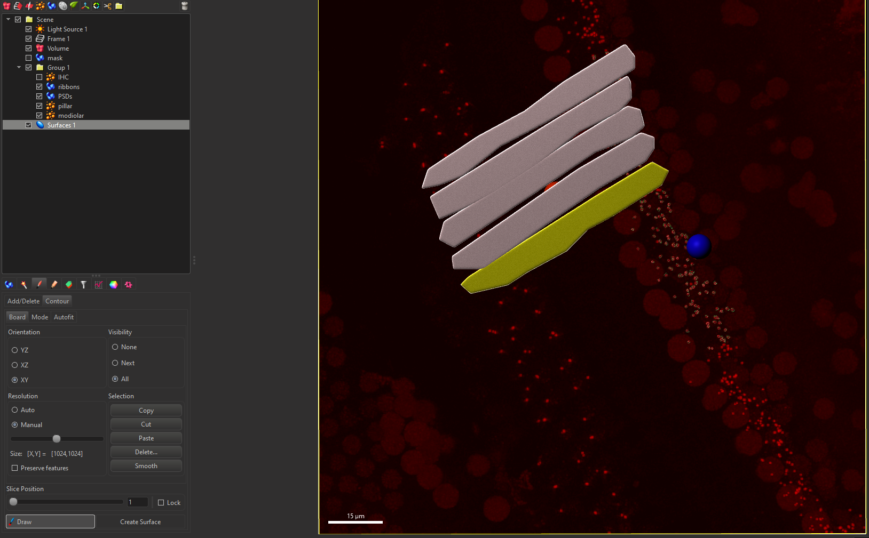

1. Select the first volume, go to Edit, select Mask Selection, set the first channel (duplicate channel before applying mask with constant inside/outside and voxels outside surface to 0) and press OK
2. Duplicate all channels of all IHCs
3. Navigate to Edit 🡪 Image Properties and name channels according to IHC number
4. Deselect the Surfaces object with the slices for masking

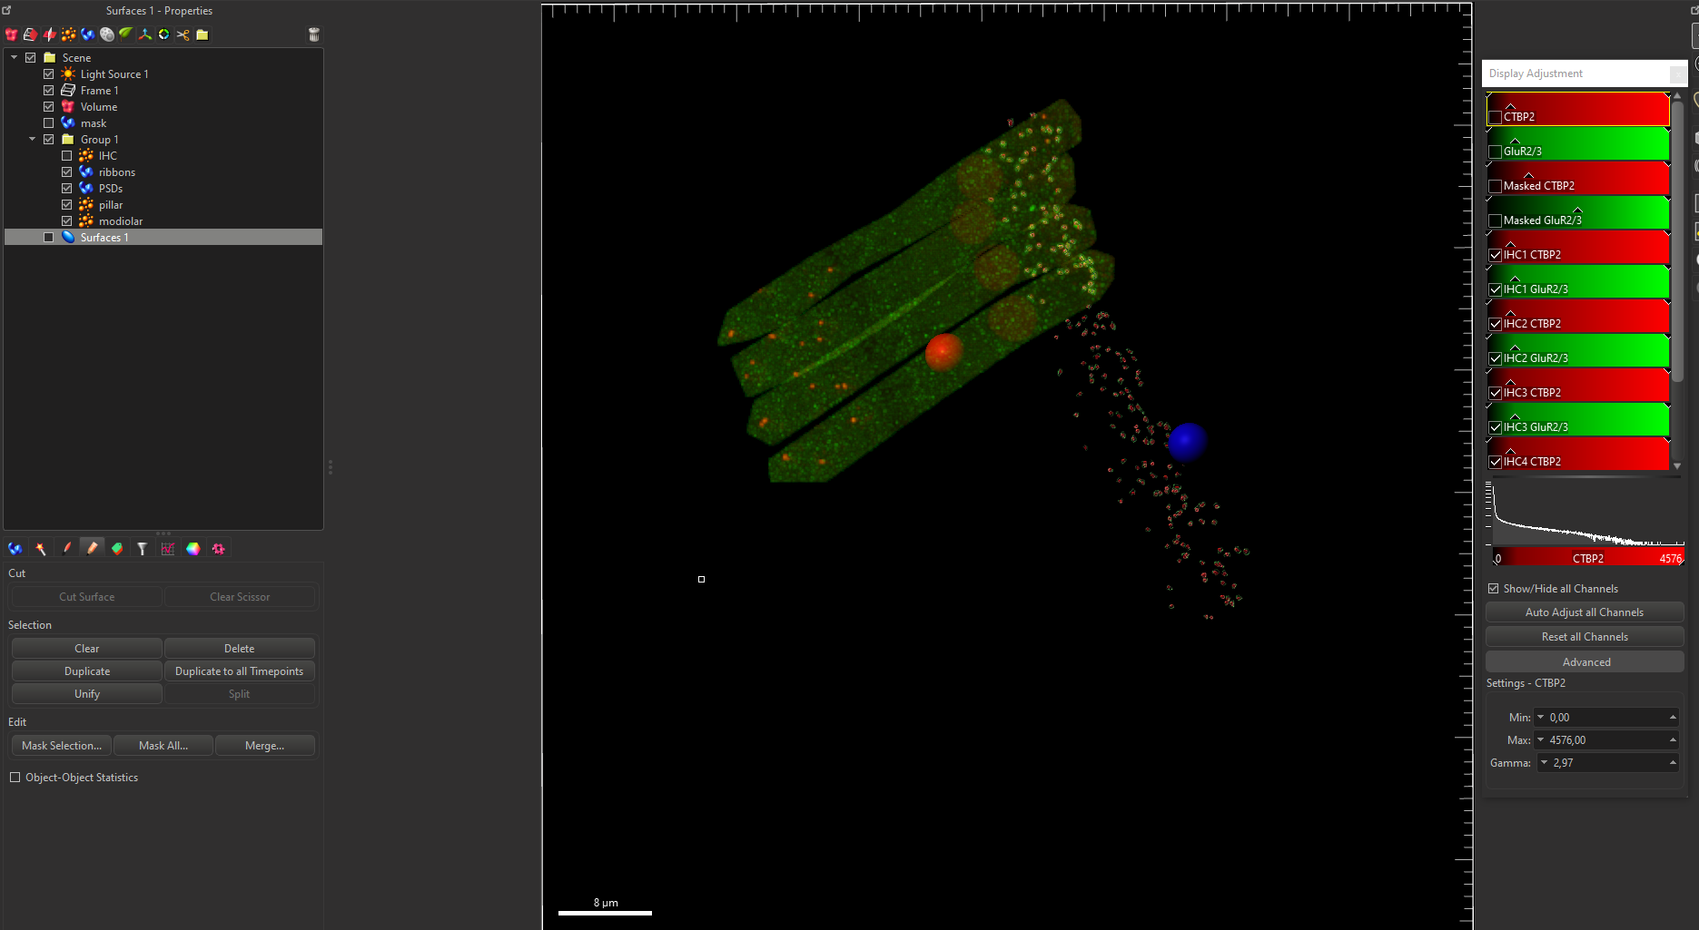

1. Navigate to the Edit Labels tab on the Ribbons object, press + under sets as many as there are IHCs and rename to IHC1… etc. Repeat for PSDs.
2. Within each set, make a class for pillar and modiolar
3. Select the ribbons of the first IHC, press assign on the corresponding set (default class, called class A)

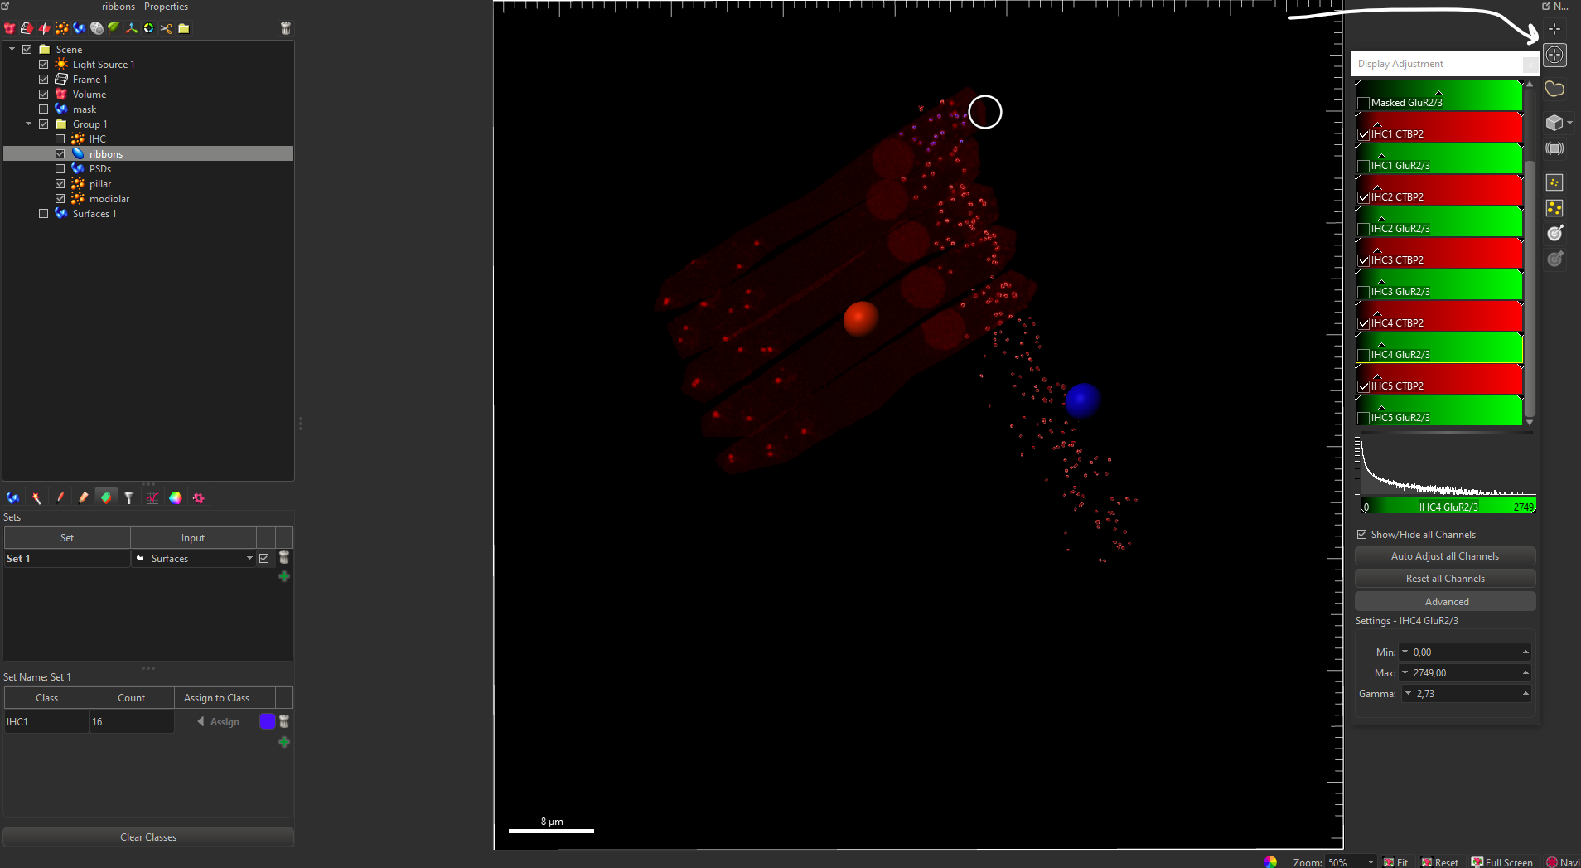

1. Classify all ribbons and PSDs to their respective IHC
2. On Display Adjustment, only select IHC1, under ribbons and PSDs, go to color, set ‘Only show objects with visible label or event’ then on the Edit Labels tab, only tick the box for IHC1
3. Take a lateral viewpoint, create as many Measurement Point objects as there are IHCs and name each
4. Set a point in the center of IHC nucleus and under the basal pole of the IHC
5. Using the multi select tool, assign Pillar ribbons to the pillar class, repeat for modiolar and delete the default class (A), repeat for PSDs, then repeat for all IHCs

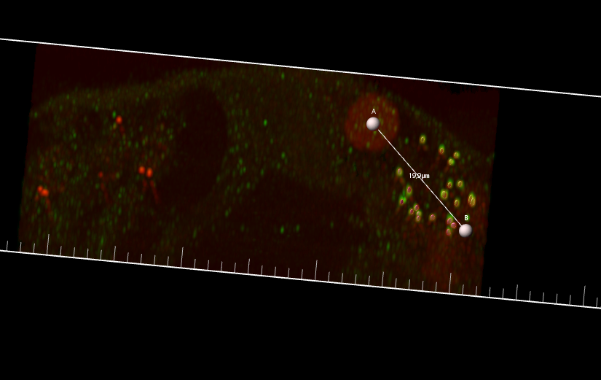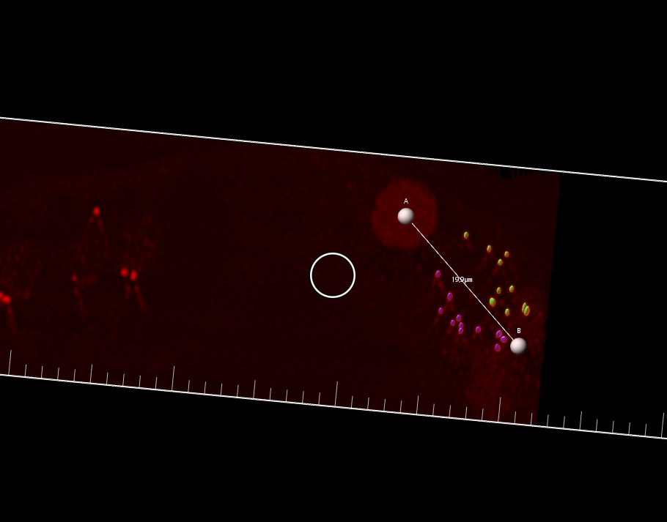

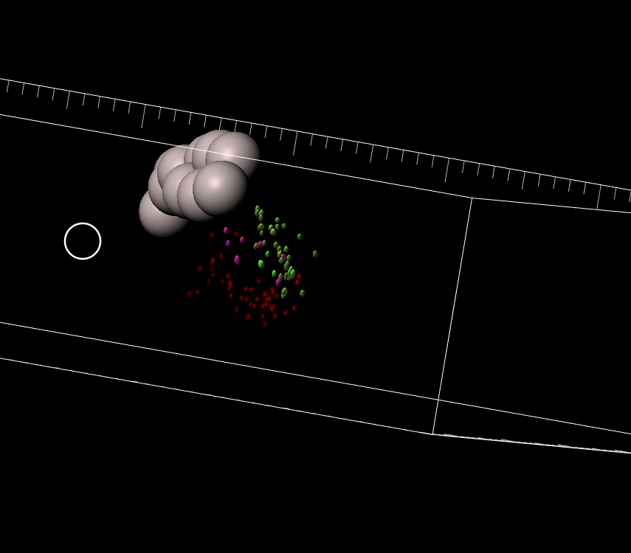

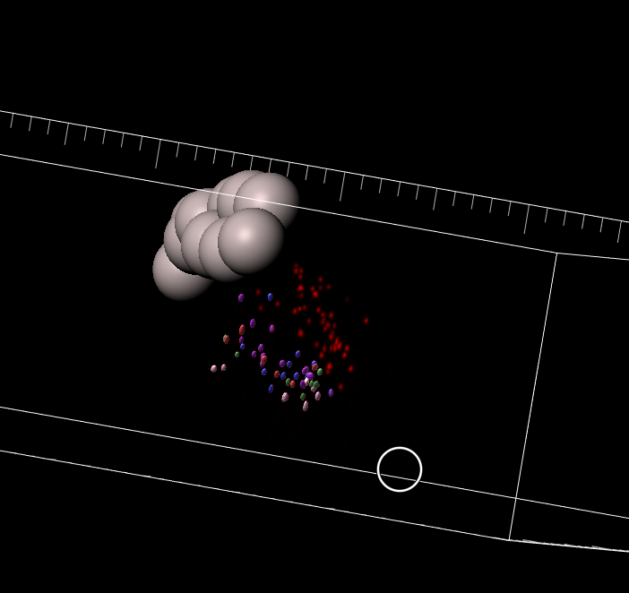

1. Select ribbons surface, navigate to statistics, make sure surface position X, Y, Z, area and volume are included using the configuration button bottom left (1) and select export all statistics on file (2)

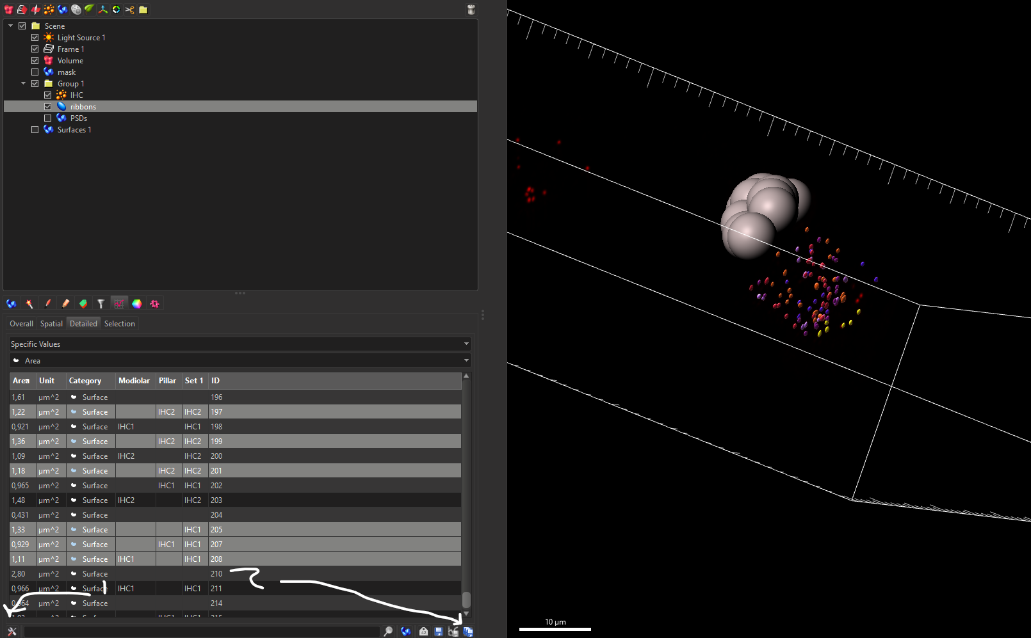

1. Export PSDs the same way